Creating a Schedule
Login to the Monitoring Portal.
https://portal.agmonitoring.com/stagesdealer/
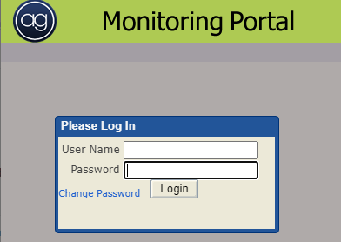
Enter the desired account number and click the binoculars to search.
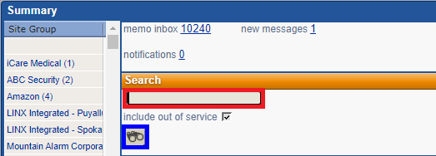
Double click on the account number
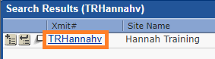
Then go to the Area & Open/Close tab.
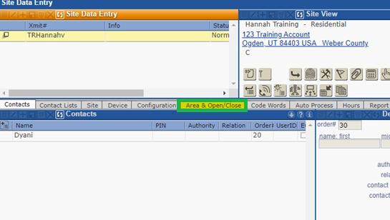
Create the Open and Close events and the schedule number that you will be creating the schedule for.
If you do not do this step, operators will not be able to access the hours in the Operator View when acting on accounts.
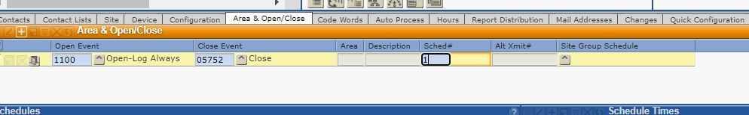

Hit the plus button under the Schedules section to generate the Detail tab for the setup of the schedule. Be sure to ask the dealer if they would like the signals to be called on or logged.
Enter any needed window times. (Window times give the subscriber a certain amount of time in minutes to open or close before generating the event).
Be sure to match the schedule number to the one you created in step 3 and its description.
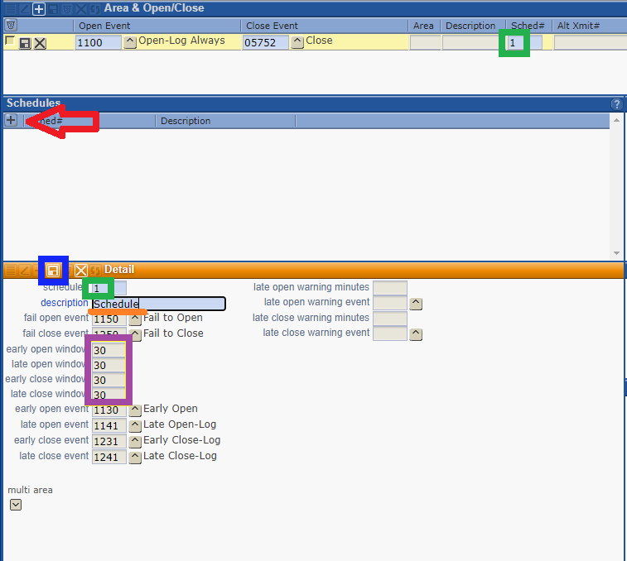
Once you have entered in the Details, you will need to save the Details to generate the time entry.
Enter in the Days of the week and times the schedule needs to be in effect for.
Remember to save this step.
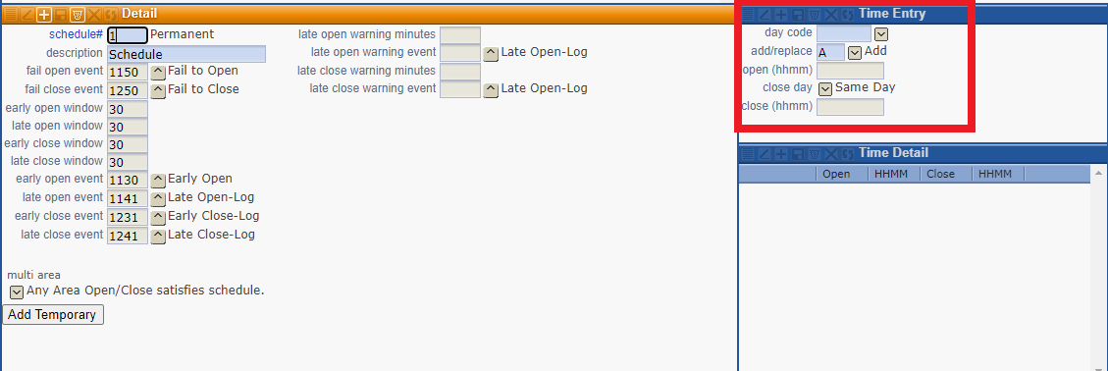
You will see the times appear in the Schedule Time box above the Time Entry.
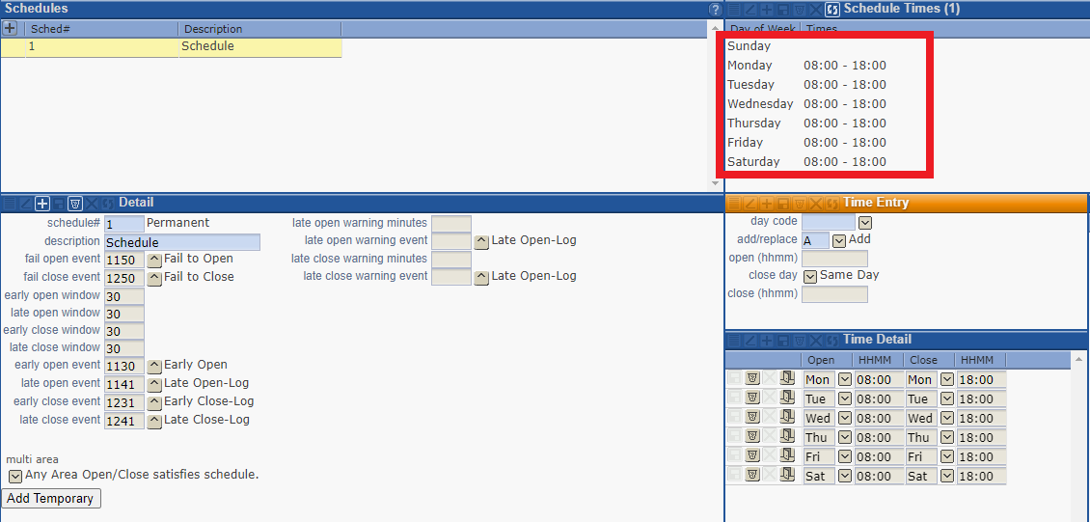
If you need to create an exception to the schedule (ex, if they close early only on Sundays) you can click the door icon next to the day.
Save.
